**Abstract: Richard Norland ‘Bend Sinster’, 1964** abstract lines that show movement

<http://www.sharecom.ca/noland/v4.html>

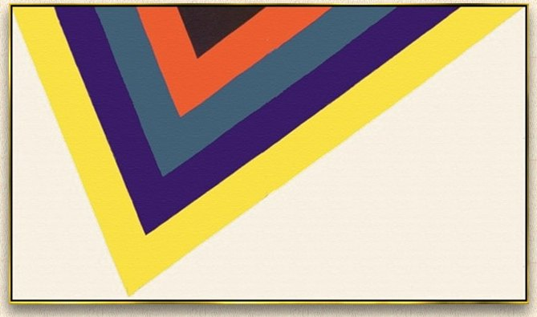

2) **Pop Art: Roy Lichenstein ‘Whaam’, 1963**, stop motion

<https://en.wikipedia.org/wiki/Roy_Lichtenstein>

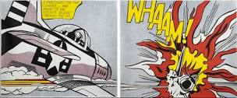

3) **Op Art: Bridget Riley ‘Current’, 1967**, lines that direct the eye

<https://en.wikipedia.org/wiki/Bridget_Riley>

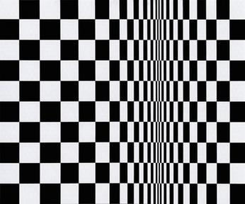

4) Dada: **Duchamp, 1916, “Nude Descending the Staircase’** repeated image to create sense of motion

<https://en.wikipedia.org/wiki/Nude_Descending_a_Staircase,_No._2>

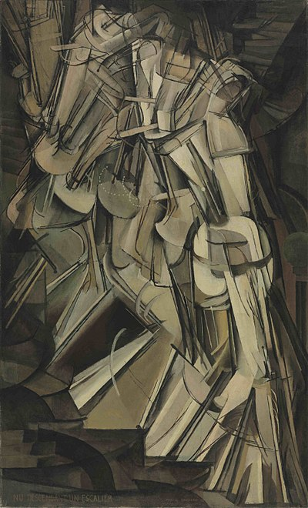

5) Op Art: **Calder “Lobster Trap and Fish Tale’**, actual movement

<https://en.wikipedia.org/wiki/Lobster_Trap_and_Fish_Tail>

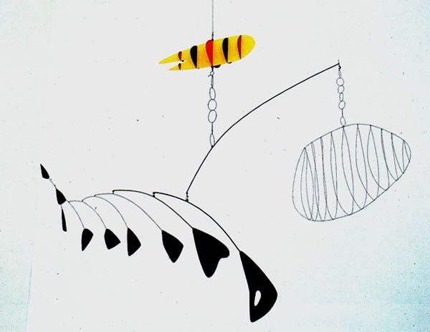

6) Graffiti Graphics: **Keith Haring, 1993**, jittery all-over movement “mural in Barcelona’

<https://en.wikipedia.org/wiki/Keith_Haring>

